|  |
| --- |
| **National University of Computer and Emerging Sciences** |
| Lab Manual 12  “Creational Design Patterns: Composite and State” |
|  |
| Object Oriented Analysis and Design |
|  |

Fall 2018

Sec B and F

Department of Computer Science

FAST-NU, Lahore, Pakistan

**Question # 1**

**Task (i)**

**Read following link to understand composite pattern.**

<https://www.tutorialspoint.com/design_pattern/composite_pattern.htm>

**Task (ii)**

The Composite composes objects into tree structures and lets clients treat individual objects and compositions uniformly. Although the example is abstract, arithmetic expressions are Composites. An arithmetic expression consists of an operand, an operator (+ - * /), and another operand. The operand can be a number, or another arithmetic expression. Thus, 2 + 3 and (2 + 3) + (4 * 6) are both valid expressions.

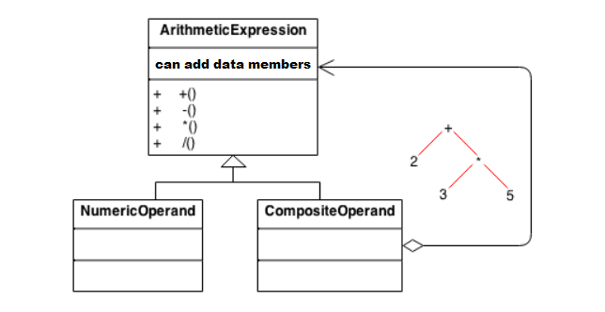

**Question # 2**

**Task (i)**

**Read following link to understand state pattern.**

<https://www.tutorialspoint.com/design_pattern/state_pattern.htm>

**Task (ii)**

We need to develop a traffic lights regulatory system. In which we have following states.

1. Green Light- It represents Move state of the vehicles.

2. Yellow Light- It warns that signal is about to change from green to red or red to green.

3. Red Light- It represents Stop state of the vehicles.

Thus, here object changes its behavior at run time and if we need to code this without using many conditional statements then state pattern is a good choice as this pattern allows an object to alter its behavior, when its internal state changes. Its state changes from Green, Yellow to Red and red to yellow and to green and based on this, traffic behavior also changes.

UML diagram for above system is given, you need to implement it.

